1. **A screenshot of a cell phone

   Description automatically generated3 + 3 + “six” + (3 + 3) * 3 % 3 6six0**
2. **(11 != 7 + 4 || 3 * 2 <= 39 % 10) == false false**
3. **54 % 10 + 8 * 3 % 9 10**

**int x = 7;**

You Totally Got This!

The value of x, y, z: 5 5 7

**int y = 5;**

**int z = 1;**

**if (x >= y) {**

**Console.WriteLine(“You Totally Got This!”);  
 if (z < y) { x = y;**

**z = x;**

**z = 7;   
 }   
}  
  
Console.WriteLine(“The value of x, y, z: ” + x + “ ” + y + “ ” + z);**

**public class amiright {  
 public void string[]args {  
 identifier = ‘TINA’;   
 Symbol = ‘’r”;   
 int age = 78;   
 CallME(78);   
}  
 static void CALLME(identifier,int age) {  
Console.WriteLine(My name is name identifier and I am age years old.);**

**}  
 }**

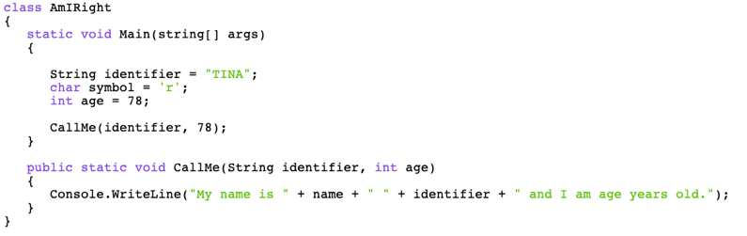**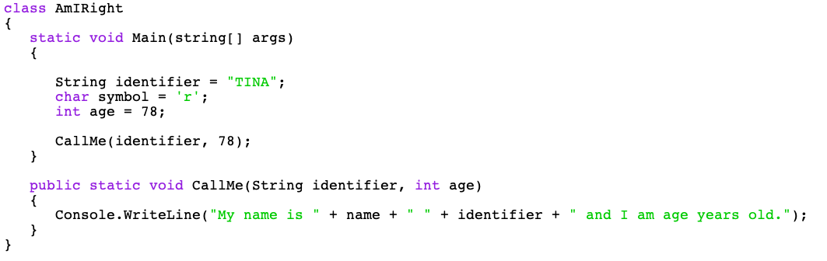

16 3 16

324

007

3-24

**public class amiright {  
 public void string[]args {  
 identifier = ‘TINA’;   
 Symbol = ‘’r”;   
 int age = 78;   
 CallME(78);   
}  
 static void CALLME(identifier,int age) {  
Console.WriteLine(My name is name identifier and I am age years old.);**